Empowering the Nation – Mobile App



This is a React Native mobile app version of the **Empowering the Nation**.  
The app allows users to view available courses, read their details (purpose & content) and select courses to calculate the total fees.

# 🚀 Features

* View **Six-Month Learnerships** and **Six-Week Short Courses**
* Tap on a course card to **select/deselect** it
* Automatic **total fee calculation** for selected courses
* Modern **dark theme UI**
* Logo + centered header title

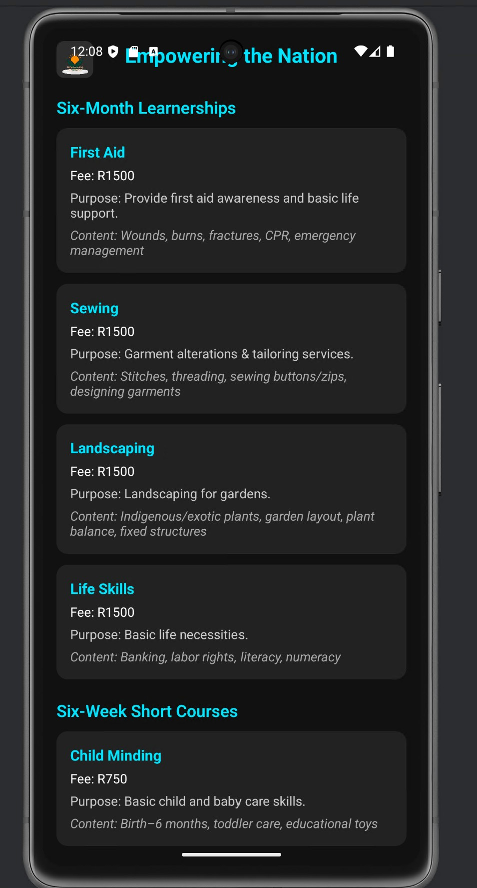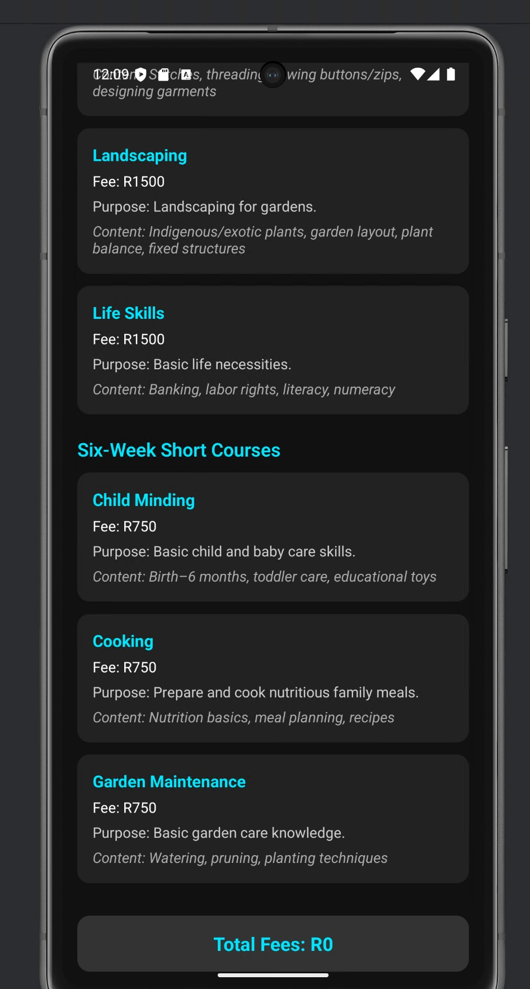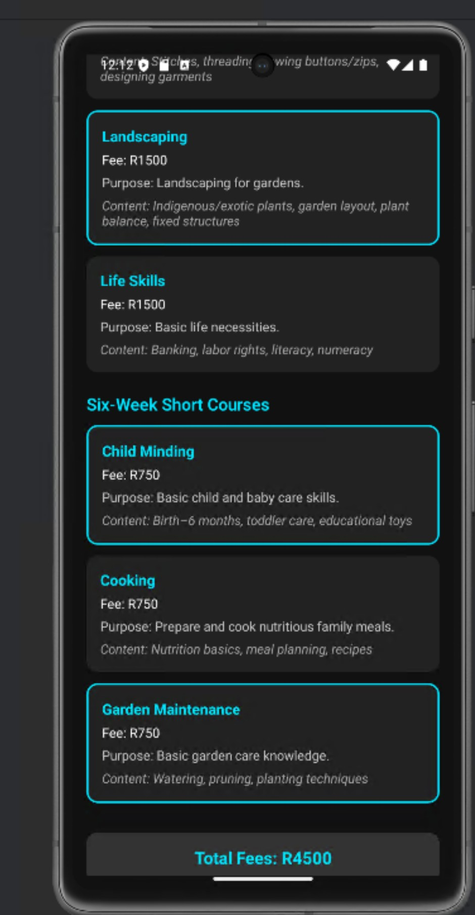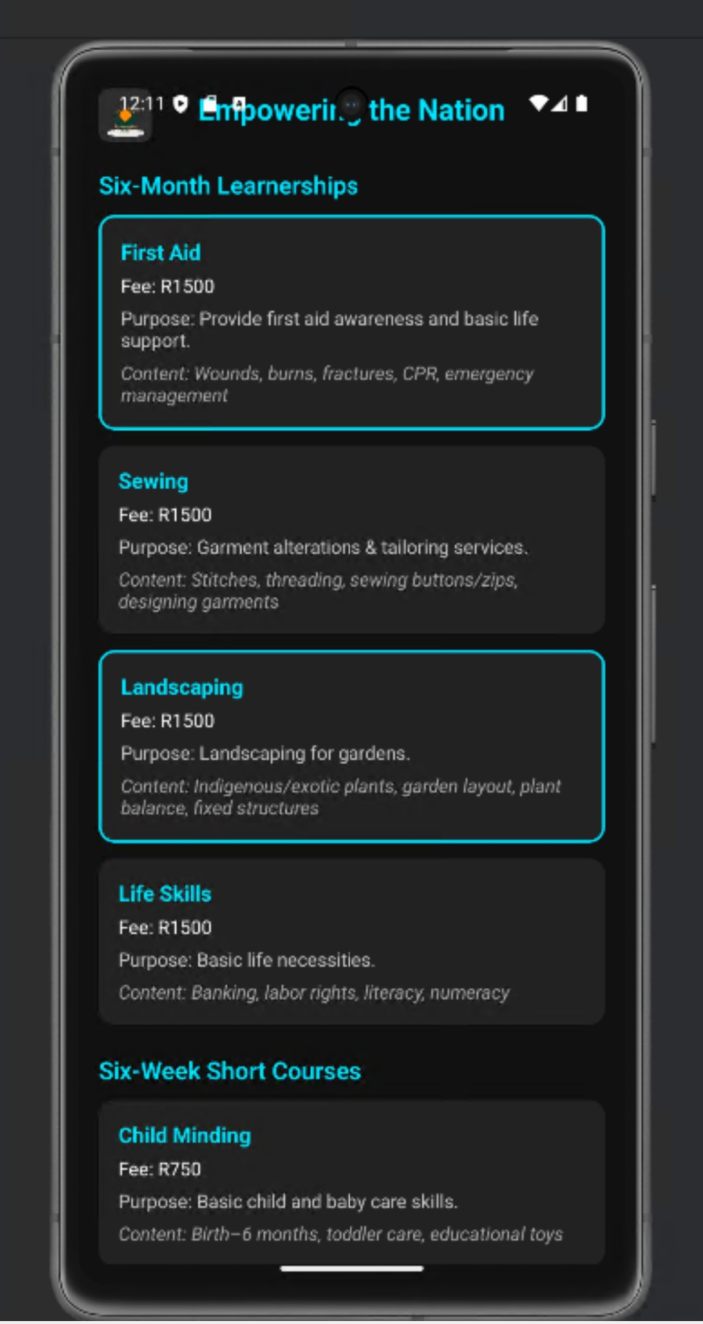

# 🛠️ Tech Stack

* React Native (Expo)
* TypeScript
* Expo Go